INVENTORY QUANTITY CALCS

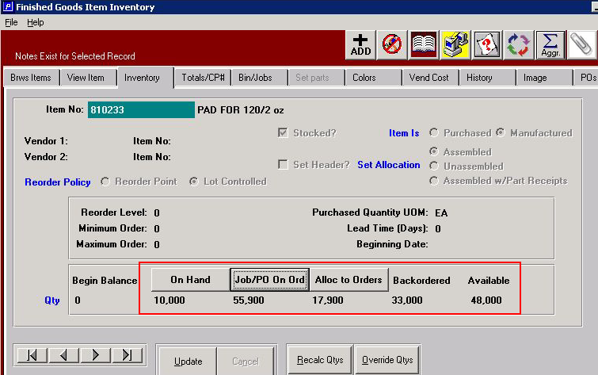

“On Hand” is a summation of the quantities by warehouse, bin and tag.
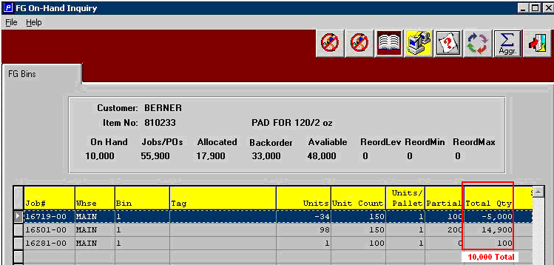

“On Order” is the open balance of customer jobs that you are running or your open PO balances with vendors for purchased items. Note the treatment of a produced quantity that is greater than the job quantity.
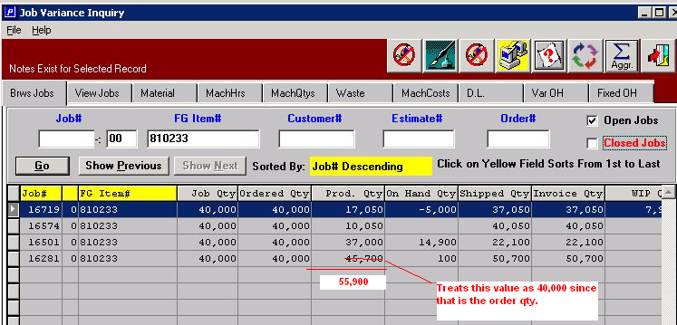

“Allocated to Orders” is the non shipped quantity of open orders.
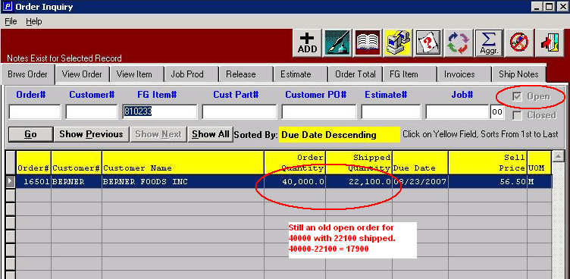

“Backordered” is a calculated field of On Order – Allocated = 55,900 – 17,900 = 38,000

“Available” is a calculated field of On Hand + On Order – Allocated = 10,000 + 55,900 – 17,900 = 48,000

